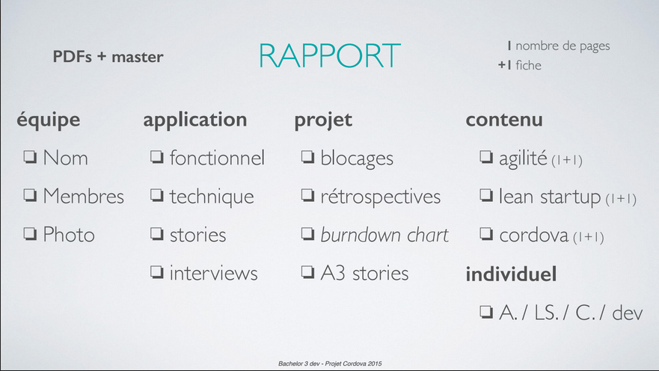

|  |  |  |  |
| --- | --- | --- | --- |
| **ÉQUIPE** | **APPLICATION** | **PROJET** | **CONTENU** |
| **Fait** | **En cours** | **En cours** | **A faire** |
| * **Erichris** | * **Erichris** | * **Siham** | **\*tous ensemble** |
|  |  | * **Elvis** |  |
|  |  |  |  |